Lesson 1

Exercise 1:

Dạng bài: Embedded answers

Đề bài: Look at the pictures and complete the word. Write NO MORE THAN 4 letters.

1.  | 2.  | 3.  | 4.  | 5. 
phone | Mexico | brother | bathroom | guitar

Exercise 2:

Dạng bài: Embedded answers

Đề bài: Write ONE word to complete the sentences.
1. Is this your pencil? → Yes, it’s my pencil.
2. Is that Emily’s bag? → Yes, it is her bag.
3. Are these your books? → No, they are my sister’s books.
4. Are those her shoes? → Yes, they are.
5. That is my brother’s bike.

Lesson 2

Exercise 1:

Dạng bài: Embedded answers

Đề bài: Look at the pictures and complete the word. Write NO MORE THAN 4 letters.

1.  | 2.  | 3.  | 4.  | 5. 
scarf | poster | gloves | head | banana

Exercise 2:

Dạng bài: Embedded answers

Đề bài: Rewrite the sentences without changing their meanings.

There is a teddy bear on the bed.
→ A teddy is on the bed.
- He knows how to ride a bike.
→ He can ride a bike.
- Tom’s country is Spain.
→ Tom comes from Spain.
- He doesn’t know how to swim.
→ He can’t swim.
- I am Elise.
→ My name is Elise.

Lesson 3

Exercise 1:

Dạng bài: Embedded answers

Đề bài: Look at the pictures and complete the word. Write NO MORE THAN 4 letters.

1.  | 2.  | 3.  | 4.  | 5. 
bread | drinks | time | soup | lemonade

Exercise 2:

Dạng bài: Embedded answers

Đề bài: Complete the sentences with the words in the box.
chicken | rice | soup | potatoes | fruit

- I had a bowl of hot soup for lunch.
- We ate grilled chicken for dinner.
- Would you like some rice with your fish?
- He peeled a potato before cooking it.
- Bananas and apples are types of fruit.

Lesson 4

Exercise 1:

Dạng bài: Embedded answers

Đề bài: Look at the pictures and complete the word. Write NO MORE THAN 4 letters.

1.  | 2.  | 3.  | 4.  | 5. 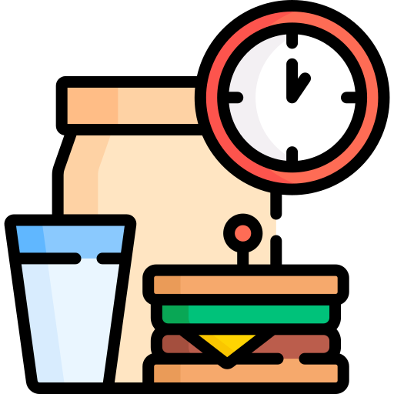
breakfast | dinner | shower | bed | lunch

Exercise 2:

Dạng bài: Embedded answers

Đề bài: Rearrange the words to make meaningful sentences
- the / I / bus / catch / at / half past / seven / every day.
→ I catch the bus at half past seven every day.
- don’t / at / six / have / I / dinner / o’clock.
→ I don’t have dinner at six o’clock.
- doesn’t / he / a shower / have / the morning / in.
→ He doesn’t have a shower in the morning.
- we / at / catch / don’t / the bus / eight / quarter to
→ We don’t catch the bus at quarter to eight.
- goes / Tom / every night / to bed / nine / o’clock / at.
→ Tom goes to bed at nine o’clock every night.

Lesson 5

Exercise 1:

Dạng bài: Embedded answers

Đề bài: Complete the sentences with the words in the box.
- I (get) get up at 6:30 every morning.
- They (not go) don’t go to bed at 9 p.m.
- (get) Does he get up at 7 o’clock?
- (catch) Do you catch the bus every day?
- She (not have) doesn’t have dinner with her family.

Exercise 2:

Dạng bài: Essay

Đề bài: You want to invite your friend to your birthday party.

Write a short invitation. Use the questions to help you.
- What is the event?
- When is it? (day and time)
- Where is it? (place/address)
- What will you do? (food, games, cake?)
- Who are you inviting?

Suggested answer
Hi Leo,
I’m having a birthday party on Saturday at 3 p.m. at my house – 12 Green Street. There will be games, music, snacks, and a big chocolate cake! We’ll also play in the garden. Please come and bring your smile!
Hope to see you soon!
From, Max

Lesson 6

Exercise 1:

Dạng bài: Embedded answers

Đề bài: Look at the pictures and complete the word. Write NO MORE THAN 4 letters.

1.  | 2. 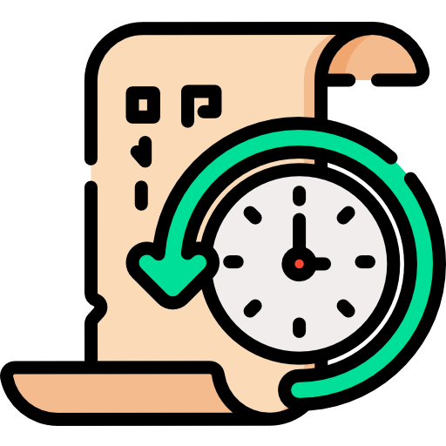 | 3.  | 4.  | 5. 
English | history | music | science | geography

Exercise 2:

Dạng bài: Embedded answers

Đề bài: Complete the sentences with the words in the box.
art | English | math | PE | history

- We read stories and write in our English class.
- I love drawing and painting in art class.
- We run and play football in PE.
- In math, we learn about numbers and how to solve problems.
- We study the past and famous people in history.

Lesson 7

Exercise 1:

Dạng bài: Embedded answers

Đề bài: Look at the pictures and complete the word. Write NO MORE THAN 4 letters.

1.  | 2.  | 3.  | 4. 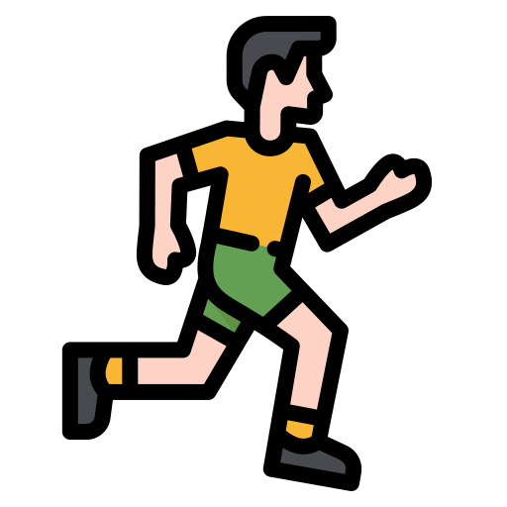 | 5. 
football | basketball | badminton | running | swimming

Exercise 2:

Dạng bài: Embedded answers

Đề bài: Rearrange the words to make meaningful sentences
- like / I / reading / books
→ I like reading books.
- she / playing / doesn’t / football / like
→ She doesn’t like playing football.
- don’t / we / watching / TV / like
→ We don’t like watching TV.
- they / swimming / like
→ They like swimming.
- he / music / likes
→ He likes music.

Lesson 8

Exercise 1:

Dạng bài: Embedded answers

Đề bài: Look at the pictures and complete the word. Write NO MORE THAN 4 letters.

1.  | 2.  | 3.  | 4.  | 5. 
athletics | yoga | cookery | coding | drama

Exercise 2:

Dạng bài: Embedded answers

Đề bài: Complete the sentences with the words in the box.
judo | film | horse riding | board games | cookery

- My sister loves cookery. She can make pizza and cake.
- I go to the sports centre on Mondays to do judo.
- We watched an exciting film at the cinema yesterday.
- My cousin does horse riding. She has a beautiful white horse.
- On rainy days, we stay inside and play board games.

Lesson 9

Exercise 1:

Dạng bài: Embedded answers

Đề bài: Use the given words to complete sentences or questions.
- I / clean / the bath / now
→ I am cleaning the bath now.
- We / not / like / run / in the rain.
→ We don’t like running in the rain.
- He / think / this film / boring.
→ He thinks this film is boring.
- She / not / have / science / every Friday.
→ She doesn’t have science every Friday.
- What / you / do / at the moment?
→ What are you doing at the moment?

Exercise 2:

Dạng bài: Essay

Đề bài: Write a short blog post about your daily life. Use the ideas below to help you.
- What time you get up and go to bed
- What you do in the morning and afternoon
- What you do after school
- What food you like and don’t like
- What activities or sports you enjoy

Suggested answer
Hi! My name is Anna. I get up at 6:30 every day. In the morning, I get dressed, have breakfast, and go to school. I have lunch at 12 o’clock with my friends. After school, I do my homework and play football. I like pizza and bananas, but I don’t like fish. In the evening, I watch TV with my family. I go to bed at 9 o’clock.

